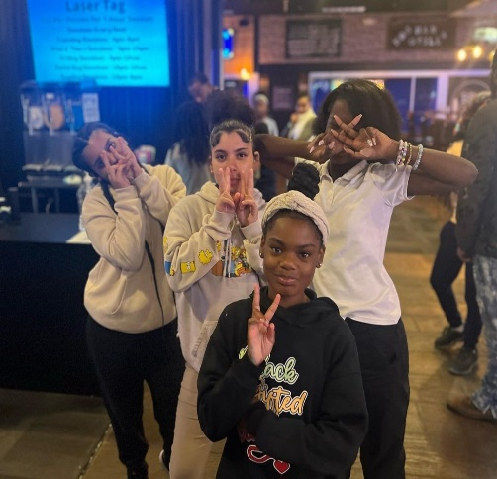
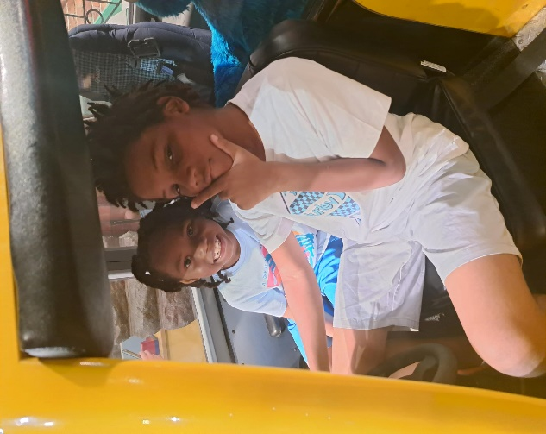
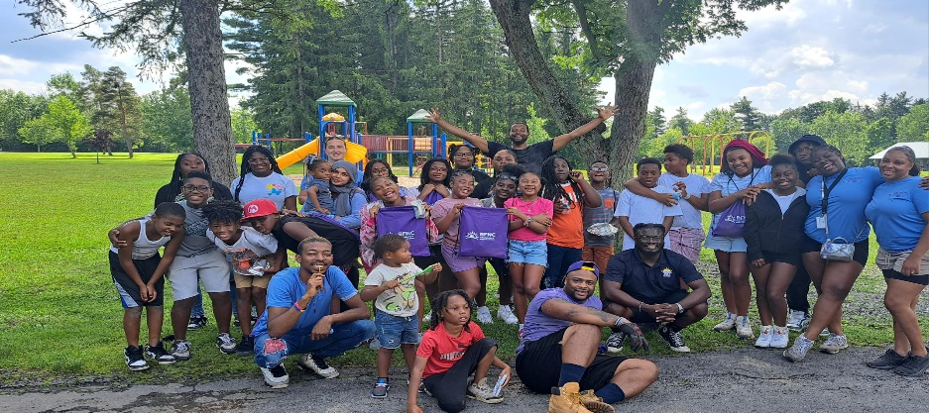

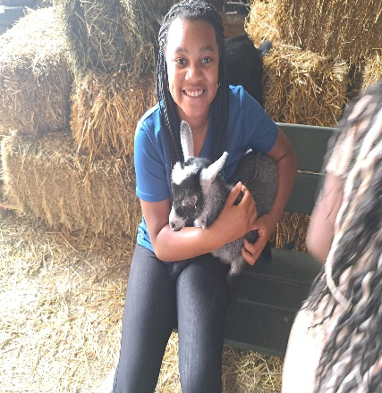
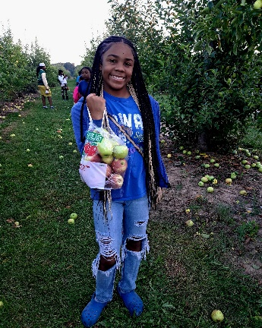

Summer Enrichment Application (Camp) 2026
Dear Parent/Guardian,
Thank you for your interest in having your child attend our CAPP Summer Enrichment Program! The BFNC CAPP initiative is a community-based project that is funded by New York State. We offer year-round youth development programming to students residing in the city of Buffalo and its surrounding areas. Our programs provide multi-dimensional educational, vocational, economic, and recreational opportunities for youth on multiple health and development topics that introduce them to new situations, ideas and people, and challenge them to build or learn new skills.
The Capp Summer Enrichment Program is a six week-long (July 6-August 14) program for youth ages 8 -13 in the Buffalo area. The purpose of the program is to promote healthy lifestyle choices, empower youth, and to have fun while building leadership and teambuilding skills. Activities include puberty workshops, sports, sexual health education, free recreational and educational field trips, leadership training, and much more!
Summer Enrichment will be held this year at BFNC’s Neighborhood House located at 76 Orange St, Buffalo, NY 14204. A healthy breakfast, lunch and snack will be provided to all participants (*free of charge) through the Buffalo Public School’s summer lunch program.

Important Information to Know Before You Register Your Child:

- Completed Registration Form and signed Waiver Release are required.
- Incomplete applications will not be accepted.
- Applications are processed on a first-come, first-serve basis.
- The CAPP Summer Enrichment Program will provide breakfast, lunch, and snacks for participants.
- Applicants must be 8 years old by July 8, 2026 (A birth certificate is required)
- Applicants must live in Erie County (A current report card is required)
- This is a no-cost program, but attendance is mandatory.
- Applications are due June 15, 2026, no later than 5:00 pm EST.
- Applicants will be notified of program acceptance via phone call.
- Attendance is required at the mandatory parent meeting.
- Return Applications to:
LaShon Webb
Return Address: Buffalo Federation of Neighborhood Centers
76 Orange St, Buffalo, NY 14204
Phone: (716) 856-0363 ext. 233

REGISTRATION FORM
Please complete this form to register your child (one child per form) for The Buffalo Federation of Neighborhood Center’s CAPP Summer Enrichment Program 2026, Erie Youth Service. This application and attached release/waiver form must be submitted for each participant to be enrolled in the program. Incomplete forms will be returned. A parent or guardian must sign this form. Be sure to print all information carefully.
Student Information
Name: |  |  | Address: |  | DOB:  ____/____/______
Age: | Sex: |  |  | Email:
Race:
African American/Black Asian White Native Hawaiian or Other Pacific Islander
American Indian or Alaska Native Other___________________
Ethnicity:
Hispanic or Latino Not Hispanic or Latino

Youth’s Telephone: |  | Social Media (ie Facebook, Twitter, Etc.):

Educational Information
School: | Grade: | Major:
Interest/Hobbies:
*Please attach a copy of the most recent report card.
Parent/Guardian Information
Name: | Address (If different than above): | Email:
Daytime Phone #: | Primary Mobile #: | Alternate Mobile #:
Emergency Contact
Name: | Relation to the Youth:
Email: | Mobile #:

COVID-19 Acknowledgement of Risk and Consent Form for Students

- The novel coronavirus (“COVID-19”) is a disease that includes several symptoms according to the Centers for Disease Control (“CDC”), such as fever or chills, cough, shortness of breath, nausea, and can lead to death. COVID-19 is contagious and means that contact with others, even those who are asymptomatic, or contact with surfaces that have been exposed to the virus, can lead to infection.
.
- Aware of the foregoing, I acknowledge and agree to the following terms as a condition of being allowed to enter the property of the Buffalo Federation of Neighborhood Centers, Inc. (“BFNC”).

- I understand and acknowledge the New York State Department of Health emergency orders, the Erie County Department of Health guidance, and the CDC guidelines regarding COVID-19. I acknowledge and understand that the circumstances regarding COVID-19 are changing from day to day and that, accordingly, state and federal orders and guidance are regularly modified and updated. I accept full responsibility for familiarizing myself with the most recent updates and complying with same at all times while on BFNC’s property.

- BFNC is dedicated to providing a safe community to its faculty, staff, students, and visitors. However, I understand that it is impossible for BFNC to prevent all risk of infection. I acknowledge that BFNC has done its best to implement recommended CDC, Department of Public Health, federal, state and local guidelines and put in place preventative measures to reduce the spread of COVID-19; however, BFNC cannot guarantee that I will not become infected with COVID-19.

- I understand that BFNC has put in place new policies and protocols in order to mitigate the spread of COVID-19. I agree to abide by the BFNC’s policies and protocols for COVID-19 at all times while on BFNC’s property.

- By signing this agreement, I acknowledge the contagious nature of COVID-19, the fact that it can be difficult to identify in another, and the inherent risk of exposure in service to BFNC to those who may be infected with COVID-19. I acknowledge the risk that I may be exposed to or infected by COVID-19 by my presence on the property or in service of the Buffalo Federation of Neighborhood Centers, Inc. and that such exposure or infection may result in personal injury, illness, permanent disability, and/or death.

- I understand and acknowledge that given the unknown nature of COVID-19, it is not possible to fully list each and every individual risk of contracting COVID-19. I understand that the risk of becoming exposed to or infected by COVID-19 at the Buffalo Federation of Neighborhood Centers, Inc. may result from the actions, omission, or negligence of myself and others, including but not limited to, employees, agents, contractors, volunteers, and students.

- I understand that in the case of possible exposures that I agree that BFNC may share my COVID-19-related information with certain employees and/or public health officials with a legitimate need to know this information.

I HAVE READ THIS FORM BEFORE SIGNING IT AND AGREE TO BE BOUND BY ITS TERMS.

Student’s/Participant’s Name: ___________________________________________________

Parent’s/ Legal Guardian’s Name: ________________________________________

Parent’s / Legal Guardian’s Signature: _________________________________________
Date signed: _______________________

Area Code and Phone Number: ________-_________- ___________

The Buffalo Federation of Neighborhood Centers CAPP Summer Enrichment Program WAIVER/RELEASE
I, ________________________, as parent/guardian of ______________________________, desire my child to participate in activities provided by The CAPP Summer Enrichment Program to be held at the Buffalo Federation of Neighborhood Centers Neighborhood House located at 76 Orange St, Buffalo NY 14204 from July 8, 2026 until August 16, 2026 and agree to the terms below:
1. Acknowledgment and Assumption of Risks: I understand and accept the nature of physical demands of the activities. I understand that the physical demands of such activities, as well as the activities themselves, may result in injury to my child, and that such injury may be severe. I have made The Buffalo Federation of Neighborhood Centers and/or The CAPP Summer Enrichment Program aware of any and all medical and physical conditions that may affect my child's participation. I understand that The Buffalo Federation of Neighborhood Centers and The CAPP Summer Enrichment Program staff employ reasonable procedures, but that unforeseen circumstances or accidental events may occur, for which The Buffalo Federation of Neighborhood Centers/ CAPP Summer Enrichment Program, its Board of Directors, representatives, volunteers, and employees cannot be held responsible.
2. Release: I, acting in my individual capacity and in the capacity as my child's parent, unconditionally waive and release The Buffalo Federation of Neighborhood Centers/CAPP Summer Enrichment Program, its Board of Directors, representatives, volunteers, and employees, and agree to hold said persons harmless from any and all claims, rights, or causes of action which may be or could be asserted against The Buffalo Federation of Neighborhood Centers/CAPP Summer Enrichment Program its Board of Directors, representatives, volunteers, and employees as the result of any physical injuries, disfigurement, medical expenses, property damage, loss of earnings, mental anguish, or loss of consortium which may occur as a direct or indirect result of my or my child's use of the services, facilities, instruction, or premises of The Buffalo Federation of Neighborhood Centers, or as a direct or indirect result of my child’s participation in activities provided by The Buffalo Federation of Neighborhood Centers/CAPP Summer Enrichment Program, or from any conduct on the part of The Buffalo Federation of Neighborhood Centers, administration , including any act or failure to act. Additionally, to the extent allowed by the law.
3. Medical Authorization and Agreement to Pay Medical Bills: In the event that my child becomes ill or injured during these activities, and I cannot be reached, The Buffalo Federation of Neighborhood Centers and The CAPP Summer Enrichment Program is authorized by me to provide first aid and to take my child to a hospital of its choice for emergency care unless I have indicated otherwise below. If there are any medical or other restrictions, I have indicated these below.
Regardless of the cause of injury, I agree to be financially responsible for any medical treatment, emergency care, transportation, or other expense related to medical care for me or my child, and I also agree that The Buffalo Federation of Neighborhood Centers and The CAPP Summer Enrichment Program are not and will not be financially responsible for any emergency care, doctor’s treatment, hospitalization, transportation, or other expense related to medical care for me or my child that arises out of activity provided by The Buffalo Federation of Neighborhood Centers or The CAPP Summer Enrichment Program.
4. Publicity: I understand that as part of The Buffalo Federation of Neighborhood Centers/ CAPP Summer Enrichment Program, my child may be videotaped, audio taped, interviewed, and/or photographed and agree to allow The Buffalo Federation of Neighborhood Centers/ CAPP Summer Enrichment Program to keep, as their property, the products of such videotaping, audio taping, interviewing, and /or photographing. I also understand that such may be used by The Buffalo Federation of Neighborhood Centers/ CAPP Summer Enrichment Program for publication in a variety of forums including The Buffalo Federation of Neighborhood Centers/ CAPP Summer Enrichment Program, website, and other publications, and that no compensation will be paid for such use.
5. Consideration: I hereby acknowledge the validity and adequacy of the consideration for this release being the offering and provision of The Buffalo Federation of Neighborhood Centers/ CAPP Summer Enrichment Program.
6. Binding Effect: This agreement is binding upon me and my spouse, heirs, assigned dependents, personal representatives, attorneys, and estates. To the extent allowed by law, this agreement is also binding upon my child or children on whose behalf it is executed and upon any legal guardian thereof.
7. Entire Agreement: This document constitutes the entire agreement between The Buffalo Federation of Neighborhood Centers/ CAPP Summer Enrichment Program, the undersigned, and his or her child regarding the subjects covered hereby. All previous agreements, oral or written, are superseded, and there exist no further oral or written representatives, promises, assurances, or statements of any kind affecting this agreement except whose which are expressly set forth in this document. I represent and warrant that I am duly authorized to act on behalf of my child in entering this agreement as either parent or legal guardian. Furthermore, if any portion of this agreement is determined to be invalid, it is agreed that the remaining balance of the agreement shall; notwithstanding, continue in full legal force and effect.

Any medical conditions of which we should be aware:

Please include any medical papers necessary in case of emergency
Any medications your child will be taking while in our program:

Non-prescription medication and prescription medication must be signed in during registration.

Hospital Preference (optional):
_____________________________________________________________________________

AGREEMENT IS ACKNOWLEDGED BY SIGNATURE BELOW:
Student’s Name: ____________________________________________
Parent’s/Legal Guardian’s Name: __________________________________________
Authorized Parent’s or Guardian’s Signature: ____________________________________
Date of Signature: ___________/____________/___________

